Online Food Ordering System

**A Project Report Submitted**

**In Partial Fulfillment of the Requirements for the Degree of**

MASTER OF COMPUTER APPLICATIONS

**by**

**Vineet Chauhan (1900290149110)**

#### Under the Supervision of

**Mr. Ankit Verma**

**KIET Group of Institutions, Ghaziabad**



#### Submitted to

**DEPARTMENT OF COMPUTER APPLICATION DR. A.P.J. ABDUL KALAM TECHNICAL UNIVERSITY LUCKNOW**

**(Formerly Uttar Pradesh Technical University, Lucknow)**

#### August 2021



**Internship Certificate**

**Mr. Vineet Chauhan,**

Welcome to **IITIAN INFOTECH**

This is to certify that Mr. Vineet Chauhan, s/o Anil Chauhan of MCA - KIET GHAZIABAD, AKTU University, has successfully completed internship for 6 months (1st January 2021 to 30th June 2021) on different technologies, using Html, PHP, and WordPress.

As a part of internship program, he had work Hard and completed theWeb Development Internship under the guidance of **Mr. Ajaydeep Singh** working in IITIAN INFOTECH.

We wish all the very best for his future endeavors.

### Yours sincerely,

AJAYDEEP SINGH

ii

**DECLARATION**

I hereby declare that the work presented in this report entitled “**Online Food Ordering System**”, was carried out by me. I have not submitted the matter embodied in this report for the award of any other degree or diploma of any other University or Institute.

I have given due credit to the original authors/sources for all the words, ideas, diagrams, graphics, computer programs, experiments, results, that are not my original contribution. I have used quotation marks to identify verbatim sentences and given credit to the original authors/sources.

I affirm that no portion of my work is plagiarized, and the experiments and results reported in the report are not manipulated. In the event of a complaint of plagiarism and the manipulation of the experiments and results, I shall be fully responsible and answerable.

Name : Vineet Chauhan Roll No. : 1900290149007

Branch : Master of Computer Application

#### (Candidate Signature)

**CERTIFICATE**

Certified that **Vineet Chauhan** (**1900290149110**) has carried out the project work presented in this report entitled “**Online Food Ordering System**” for the award of **Master of Computer Application** from Dr. A.P.J. Abdul Kalam Technical University, Lucknow under my supervision. The report embodies result of original work, and studies are carried out by the student himself and the contents of the report do not form the basis for the award of any other degree to the candidate or to anybody else from this or any other University.

**Mr. Ankit Verma**

Internal Examiner External Examiner

Assiteant Professor

**Department of Computer Application**

**KIET GROUP OF INSTITUTIONS,**

**GHAZIABAD**

**Abstract**

Online food Ordering System by Vineet Chauhan is a part of e-commerce. E-commerce or business through net means distributing, buying, selling, marketing, and servicing of products or services over electronic systems such as the Internet and other computer networks. Thus, if we own a restaurant, we need to upload meal online to attract potential Railway customers.

The Online food ordering system gives restaurants the ability to increase sales and expand their business by giving customers the facility to order food online.

With an online restaurant menu ordering system, customers can place orders online 24 *7. Thus, it is a simple, fast, and convenient food ordering system giving an edge over the competition at an affordable price.

Internet has seen a tremendous growth in terms of coverage and awareness. So, giving the business an online presence has become very crucial and important.

With [online food ordering], we can set up restaurant Meal online and the customers can easily place order with a simple mouse click. Also, with a food meal online we can easily track the orders, maintain customer's database, and improve the food delivery service. We can receive order through customer request directly view on internet.

The restaurants can even customize online restaurant menu and upload images easily. Having restaurant meal on internet, potential customers can easily access it and place order at their convenience.

Online food ordering is a website designed primarily for use in the food delivery in Railways. This system will allow hotels and restaurants to increase scope of business by reducing the labor cost involved. The system also allows to quickly and easily manage an online menu which customers can browse and use to place orders with just few clicks. Restaurant employees then use these orders through an easy to navigate graphical interface for efficient processing.

**ACKNOWLEDGEMENTS**

I would like to express my special thanks of gratitude to my trainer **Mr. Ajaydeep Singh** as well as for her guidance, help and encouragement throughout my research work. Their enlightening ideas, comments, and suggestions.

My gratitude to my other office colleges and seniors, for here administrative help at various occasions. I am thankful to them.

Secondly, I would also thanks to my parents, teachers, and friends who me helped a lot in finishing this project within a limited time. Without their support, completion of this work would not have been possible in time. They keep my life filled with enjoyment and happiness.

**Vineet Chauhan 1900290149110**

**List of Figures**

Fig 2.1 Software Overview 13

Fig 3.1 Activity Diagram 17

Fig 3.2 Web Ordering system 18

Fig 4.1 Design 20

Fig 4.2 Ordering Diagram 21

Fig 4.3 Content Order 22

Fig 4.4 Update Order 22

Fig 4.5 Payment Status 23

Fig 4.6 Issue Report 24

**List of Tables**

Table 1.1 Hardware Requirement 14

|  |  |  |
| --- | --- | --- |
|  | **TABLE OF CONTENT** |  |
|  | Page No. |
| Training Certificate | ii |
| Declaration | iii |
| Certificate | iv |
| Abstract | v |
| Acknowledgement | vi |
| List of Figure | vii |
| List of Table | viii |
| **CHAPTER 1-** | **INTRODUCTION** | **11-15** |
| 1.1 | OBJECTIVE | 11 |
| 1.2 | MOTIVATION | 12 |
| 1.3 | AIM OF SOFTWARE | 12 |
| 1.4 | FEATURES | 12 |
| 1.5 | BACKGROUND RELATED WORK | 13 |
| 1.6 | ADVANTAGE | 14 |
| 1.7 | PROJECT PERPECTIVE | 14 |
| 1.8 | SOFTWARE REQUIREMENTS | 14 |
| 1.9 | HARDWARE REQUIREMENTS | 15 |
| **CHAPTER 2-** | **LITERATURE REVIEW** | **16-18** |
| 2.1 | IMPLEMENTING CUSTOMIZABLE | 16 |
| 2.2 | ANALYSIS OF CUSTOMER ATTRIBUTE | 16 |
| 2.3 | CUSTOMER PERCEPTION | 17 |
| 2.4 | THE CURRENT STATE | 17 |
| 2.5 | FOOD ORDERING SYSTEM USING PHONES | 17 |
| 2.6 | E-FOODCART: AN ONLINE FOOD ORDERING | 18 |
| 2.7 | LOYALITY TOWARDS ONLINE FOOD DELIVERY | 18 |
| **CHAPTER 3-** | **SYSTEM MODEL** | **19-21** |
| 3.1 | WEB ORDERING SYSTEM | 19 |
| 3.2 | MENU MANAGEMENT | 20 |
| 3.3 | ORDER RETRIVAL SYSTEM | 20 |
| 3.4 | PRODUCTION FUNCTION | 20 |
| **CHAPTER 4-** | **ER DIGRAM** | **22-24** |
| 4.1 | ACTIVITY DIAGRAM | 22 |
| 4.2 | ALL USER TO SYSTEM FEATURE |  |
|  | 4.2.1 “Home” menu option | 23 |

|  |  |  |  |
| --- | --- | --- | --- |
| 4.2.2 | | About | 23 |
| 4.2.3 | | Cart (x)” menu option | 23 |
| 4.2.4 | | Log In | 24 |
| 4.2.5 | | Add Category | 24 |
| 4.2.6 | | Add Product | 24 |
| **CHAPTER 4-** | **DESIGN** | | **25-30** |
| 5.1 | FEASIBILITY STUDY | | 25 |
| 5.2 | DESIGN | | 26 |
| **CHAPTER 5-** | **NON-FUNCTIONAL REQIREMENTS** | | **31-29** |
| 6.1 | HARDWARE LIMITATION | | 31 |
| 6.2 | INTENDED AUDIENCE AND READINGSUGGESTIONS  6.2.1 Developer | | 33 |
|  | 6.2.2 User | | 33 |
|  | 6.3.3 Tester | | 33 |

CHAPTER 7- GRAPHICAL USER INTERFACE 34

GLOSSARY 46

CONCLUSION 47

REFRENCES 48

CODING 48-90

**CHAPTER 1**

#### INTRODUCTION

An Online food ordering system is a web-based application that stimulates the foodies (customers) to put food orders through internet by locating their favorite restaurant or nearest one. This application is based on the asp.net platform.

It is known globally that, in today’s market, it is extremely difficult to start a new small-scale business and live-through the competition from the well-established and settled owners. In fast paced time of today, when everyone is squeezed for time, most people are finicky when it comes to placing a food order. The customers of today are not only attracted because placing an order online is very convenient but also because they have visibility into the items offered, price and extremely simplified navigation for the order.

Online ordering system that I am proposing here, greatly simplifies the ordering process for both the customer and the restaurant. System presents an interactive and up-to-date menu with all available options in an easy-to-use manner. Customer can choose one or more items to place an order which will land in the Cart. Customer can view all the order details in the cart before checking out. At the end, customer gets order confirmation details. Once the order is placed it is entered in the database and retrieved in pretty much real time. This allows Restaurant Employees to quickly go through the orders as they are received and process all orders efficiently and effectively with minimal delays and confusion.

* 1. **OBJECTIVE**

The main objective of this project is to develop an application which gives provision to the Restaurant owners to flourish their business by uploading menus at no cost and will invariably lead to higher customer retention and acquisition rates.

* 1. **MOTIVATION**

The motivation for designing this application came because while travelling in Railways my family is sufferer of good food and I personally do not like waiting for long in the store or to have to call store to place an order to pantry . Moreover, I value recent learning about the php Programming languages as well as seeing how powerful and dynamic they are when it comes to web designing and applications. The languages used to build this application are PHP, CSS, HTML and SQL at client facing. I found them to be extremely useful while working on the technologies.

* 1. **AIM OF THE SOFTWARE**

This software is developed to help computer science students to learn about the Web application designing using PHP and HTML from their basic capabilities to build a complete working application from 5 scratch. Further, it gives insight about how GUI interacts with SQL, CSS, ETC.

* 1. **FEATURES**
* Online food (original and searchable format) Provision of restaurant owners to register themselves with their menu.
* Easy lookup of restaurants.
* Simple, fast, and convenient ordering of food
* Availability of the Meal online 24*7*365 – no need to recite the complete menu over the phone. An online food is ready to be viewed and printed by people worldwide.
* Accurate – no more spelling out the dishes’ names.
* Menu with the actual pictures of the product thereby adding to the uniqueness of your online

2

presence.

* Prior knowledge of time for delivery helps prepare and provide better service.
* Receive direct customer feedback and suggestions.
* Keep the customers informed.
  1. **Background and Related Work**

This Case study looks at the problem of setting up a fast-food restaurant. In existing system there are few problems:

* For placing any orders customers must visit hotels or restaurants to know about food items and then place order and pay. In this method time and manual work is required.
* While placing an order over the phone, customer lacks the physical copy of the menu item, lack of visual confirmation that the order was placed correctly.
* Every restaurant needs certain employees to take the order over phone or in-person, to offer a rich dining experience and process the payment. In today’s market, labor rates are increasing day by day making it difficult to find employees when needed. Hence, to solve this issue, what I propose is an “Online Food Order System, originally designed for small-scale business-like College Cafeterias, Fast Food restaurant or Take-Out, but this system is just as applicable in any food delivery industry.

The main advantage of my system is that it greatly simplifies the ordering process for both the customer and the restaurant and greatly lightens the load on the restaurant’s end, as the entire process of taking orders is automated. Anticipated Benefits are:

1. This will minimize the number of employees at the back of the counter.
2. The system will help to reduce labor cost involved.
3. The system will be less probable to make mistake since it’s a machine.
4. This will avoid long queues at the counter due to the speed of execution and number of optimum screens to accommodate the maximum throughput.
   1. **ADVANTAGE**

* Reduce time-consuming phone orders and eliminate illegible fax orders.
* No more busy phones or the requirement for extra phone lines.
* An edge over the competition at an affordable price.
* Broader customer reach across regions.
* Builds a customer database.
* Provides a channel for marketing and promotion lowering your advertising cost.
* Helps in improved service.
* Greater customer satisfaction!!!
  1. **PRODUCT PERSPECTIVE**

The online food ordering application is a web-based system. It can be accessed using IE 10.0 and above, Fire Fox 31 and above and Google Chrome.

* 1. **SOFTWARE REQUIREMENTS**
     + Operating system
     + Windows 2000/Professional/XP
     + Front-end
     + ASP.Net, C#
     + Back-end
     + SQL Server 2005
  2. **HARDWARE REQUIREMENTS**

Table 1.1 Hardware Requirement

|  |  |
| --- | --- |
| Processor | 450 MHz Pentium II-class processor  600MHz Pentium III-class or IV processor |
| Operating system | Standard editions can be installed on any of the following systems: -  Microsoft windows server 2003  Windows XP Home edition |
| Memory | 512MB for both Microsoft windows server 2003 and Windows XP Home edition |
| Hard Disk | Minimum space required to install .NET=3.5GB |

**CHAPTER 2 LITERATURE REVIEW**

* 1. **Implementing customizable: -**

Typically, in a restaurant food order process involves several steps for ordering the food where firstly customer starting from browsing the paper-based menu and then inform to the waiter for ordering items. [1]

Usually, the process require that the customer has to be seated before starting. An alternative method for the customers is “Food Pre-Order System using Web Based Application” in which customer can be able to create the order before they approach the restaurant. Customer using Smartphone. When the customer approach to the restaurant, the saved order can be confirmed by touching the Smartphone.[2]

The list of selected pre-ordered items shall be shown on the kitchen screen, and when confirmed, order slip shall be printed for further order processing. The solution provides easy and convenient way to select pre-order transaction form customers.[3]

* 1. **Analysis of Customer attitudes: -**

While e-commerce is rapidly spreading around the world, the food industry also began to take its‟ place in this growing area. The purpose of this study is to investigate the factors that influence the attitude of internet users towards online food ordering in Turkey among university students.[4]

It uses the Technology Acceptance Model (TAM) (Davis, 1986) as a theoretical grounding to study adoption of using the Web environment for ordering food. In addition to TAM; Trust, Innovativeness and External Influences are added to the model as main factors that influence internet users attitudes.[5]

The research universe is composed of undergraduate and graduate students. Studying a homogeneous group allows us to overcome potential side effects of studying a heterogeneous group with diverse internet usage habits.[6]

* 1. **Customer Perception: -**

According to Serhat Murat Alagoz & Haluk Hekimoglu (2012), e-commerce is rapidly growing worldwide, the food industry is also showing a steady growth. In this research paper they have used the Technology Acceptance Model (TAM) as a ground to study the acceptance of online food ordering system.[7]

Their data analysis revealed that the attitude towards online food ordering vary according to the ease and usefulness of online food ordering process and also vary according to their innovativeness against information technology, their trust in eretailers and various external influences.[8]

* 1. **The Current State of Online Food Ordering System: -**

A study of 372 U.S. restaurant operators (of all sizes) that accept takeout orders found that about one-quarter of those surveyed have adopted online ordering. These restaurateurs have been pleased with the technology, and all of them indicated that online ordering has met or exceeded their expectations on ROI.[9]

Although convenience and control are both drivers of the move toward online ordering, this study found that consumers and operators differed on the ranking of those two factors. Operators thought that consumers like online ordering for its convenience, but an earlier study of consumers found that what they like is control over the ordering process. Contrary to some reports, the restaurants in this study did not find substantial increases in average check, but they did report considerable increase in order frequency.[10]

For this sample, the top benefit of online ordering was a savings in labor, since employees are not tied up on the phone or at the counter. Order accuracy was another benefit cited by these restaurant operators.[11]

* 1. **Food Ordering System using Mobile Phone: -**

This project works is aimed for developing an efficient food ordering system that can be used in the food & beverage (F&B) industry which can help the restaurants to quickly and easily manage daily operational task as well as improve the dining experience of customers. It is believed that still have a lot of restaurants are using the traditional method for food ordering processes.[12]

By using the traditional method, it arise a lot of human error while the restaurant’s employees deal with large amount of customers, this issue will did a great impact to the restaurant in terms of profitability. Thus, this project is to propose a suitable food ordering system for F&B industry to solve the problem that mentioned above.[13]

The system will become an important tools use for restaurant to improve the management aspect by utilizing computerized system to coordinate each and every food ordering transaction instead of traditional method. In addition, it can also provide efficiency for the restaurant by reducing time consuming, minimize human errors and providing good quality customer service. In terms of the integrity and availability of the system provided, it can be concluded that this system is a suitable solution for the F&B industry.[14]

* 1. **E-FoodCart: An Online Food Ordering Service: -**

With the advancement of new technologies especially mobile devices has made food ordering via online applications become more popular. The traditional method of taking orders in restaurants involving pen and papers to note down orders has becoming less as it is quite slow and tend to cause mistakes in taking the orders.[15]

Based on, food ordering online traffic is 300% faster than dine-in traffic among the young generations since it is more timesaving and more convenient in selecting their menus. Moreover, from several observations on online market versus in-store shopping, e-commerce is growing three times faster compared to the traditional retail.[16]

Since millennials prefer online shopping, and are the largest generation of consumers, most services focus more on this generation. In addition, virtual card method of payments such as Google Pay, and Boost has becoming more popular. It gives advantages such as lighter wallet, safe and secure, easier to use, and paper-saving.[17]

* 1. **Loyalty toward online food delivery service: -**

The progress in internet technology which facilitates the e-commerce activities has altered the behavior of both consumers and firms. The availability of e-commerce platforms as a shopping medium enables customers to shop conveniently, compare products and prices effectively, and arrange the delivery of the product immediately (Chang, Chou, & Lo, [2014](https://www.tandfonline.com/doi/full/10.1080/15378020.2018.1546076); Yeo, Goh, & Rezaei, [2017](https://www.tandfonline.com/doi/full/10.1080/15378020.2018.1546076)). In the restaurant context, the availability of online technology enables customer to order the food through restaurant websites or via online food delivery services such as Eat24, GrabFood, and GoFood.[18]

For the restaurant industry, the availability of online delivery service technology enables the industry, which is in a saturated market, to improve order accuracy, increase productivity, and enhance customer relationship (Kimes, [2011](https://www.tandfonline.com/doi/full/10.1080/15378020.2018.1546076)), and extend their market (Ng, Wong, & Chong, [2017](https://www.tandfonline.com/doi/full/10.1080/15378020.2018.1546076); Yeo et al., [2017](https://www.tandfonline.com/doi/full/10.1080/15378020.2018.1546076)).[19]

**CHAPTER-3**

**SYSTEM MODEL**

**sdsdss**

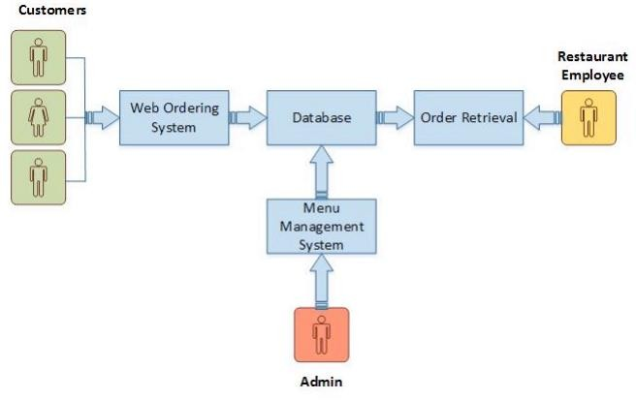

Fig 3.1 **System Model**

The structure of the system can be divided into 3 main logical components:

* 1. **Web Ordering System**- Provides the functionality for customers to place their order and supply necessary details.
  2. **Menu Management** - allows the restaurant to control what can be ordered by the customers
  3. **Order Retrieval System -** This is a final logical component. Allows restaurant to keep track of all orders placed. This component takes care of order retrieving and displaying order information.
  4. **Product Function:** The Online Food Order System application would have the following basic functions: Web Ordering System Module This module provides the functionality for customers to place their order and supply necessary details. Users of the system, namely restaurant customers, must be provided the following functionality:
* Create an account.
* Manage their account.
* Log in to the system.
* Navigate the restaurant’s menu. 7
* Select an item from the menu.
* Add an item to their current order.
* Review their current order.
* Remove an item/remove all items from their current order.
* Provide payment details.
* Place an order.
* Receive confirmation in the form of an order number.
* View order placed. Additional Feature:

. This will allow to simplify the overall user experience. Menu Management System Module This module provides functionality for the power user-Administrator only. It will not be available to any other users of the system like Restaurant Employees or Customers. Using a graphical interface, it will allow an Admin to manage the menu that is displayed to users of the

web ordering system: • Add/update/delete food category to/from the menu. • Add /update/delete food item to/from the menu. • Update price for a given food item. • Update additional information (description, photo, etc.) for a given food item. Before customers can actually use this system, functionality provided by this component will have to be configured first. Once the initial configuration is done, this will be the least likely used component as menu updates are mostly seasonal and do not occur frequently. Order Retrieval System Module This is the most simplest module out of all 3 modules. It is designed to be used only by restaurant employees, and provides the following functions: • Retrieve new orders from the database. • Display the orders in an easily readable, graphical way. 8 Implementation Hardware/Software Interface: This section lists the minimum hardware and software requirements needed to run the system efficiently. Hardware Interface: • Pentium Processor • 60 MB of free hard-drive space • 128 MB of RAM Software Interface: • Operating System: Windows (Vista/7 or above) • Web Browser: IE 10 or above, Mozilla FF 31 and above or Google Chrome

**CHAPTER 4**

**ER DIAGRAM**

* 1. **Activity Diagram:** This section lists the activity diagram and describes the flow of the activities in the system. A detailed description is then given after the figure for each activity. Provides the overview of the activity of the Online food Order System application.

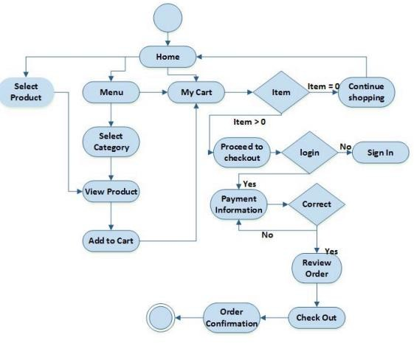

Fig 4.1 **Activity Diagram**

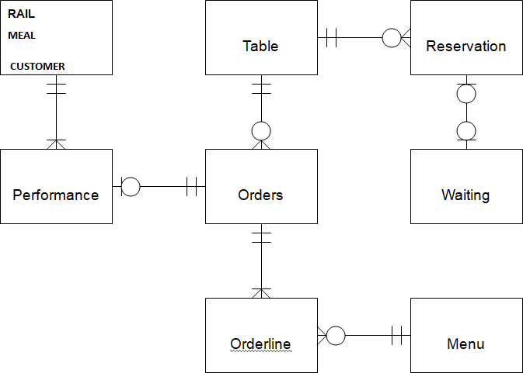

Fig 4.2 **Web Ordering Diagram**

* 1. **All users of the system, are provided with below menu options:**

Home, About, login, Cart, and Contact Web Ordering System Module Customers of the Web Ordering system will interact with the application through an easy-to-use top navigation meal.

* + 1. **“Home” menu option**: Allows the users to see all food items offered with nice images as well as select an item to place an order.
    2. **About:** A ‘Drop-Down’ menu, allows users to see all food items per category. Item can then be added to the cart using a single button click.
    3. **Cart (x)” menu option**: - Allows users to see details of the items placed in cart. Details include Item #, Product Name, Product Image, Product Description, Quantity, Unit Price, Total per item and final Total of the order. It also allows ‘Update’ and ‘Delete’ an item using single button click. User can then use a ‘Proceed to checkout’ button to proceed further. - Once, Check Out button is selected, user will be prompted for the Sign In/Sign Up process if not logged in else user will be presented with a simple “Payment Information” form. User will be asked to provide all required details in displayed text boxes and make appropriate Dropdown selections. Then, all this information can be saved using a ‘Save’ button. - User will then be presented with a “Review Order” page, which will display Payment Information along with Order details to review. User can then use a ‘Check Out’ button to place an order.

- Once order is placed, user will be presented with appropriate Order confirmation success/failure message.

* + 1. “**LOG IN**”: A “Drop Down” menu will display the user orders, Sign In and Sign Out options. • eClub- Allows user to subscribe to eClub to get promotional deals and discounts offers. Menu Management System Module Similar to Web ordering system, this module presents Admin with below additional options under “MyAccount” Drop down menu:
    2. **Add Category:** Allows to add a food Category name in a simple form.
    3. **Add Product:** Allows to add Product Name, Description, Price and choose Category in a simple form along with Product Image.
    4. **Modify Product:** Allows updating or deleting product details. Order Retrieval System Module The application will automatically fetch new orders from the database at regular intervals and display the order numbers.
* Under “MyAcoount’ menu a customer will be able to see only his/her order whereas a Restaurant Employee or an Admin can see all users orders.
* To view the details of an order, the user must click on that order number, which will display all order details This structure can intuitively be expanded and collapsed to display only the desired

information.

**CHAPTER 5 DESIGN**

#### FEASIBLITY STUDY

A feasibility study evaluates the project’s potential for success; therefore, perceived objectivity is an important factor in the credibility of the study of the potential investors and lending institutions.

The software uses technologies such as JAVA, SWING, AWT and JFREECHART these technologies are currently being used in IT industry, open source being easily modifiable as per requirements and easily available on internet for studying purpose so all the possibilities of infeasibility are outlawed. It is abiding the protection rights of all and is lawful in its application and implementation. Schedule feasibility is a measure of how reasonable the project timetable is. Based on this, our project's time period has been four months. Completion of the proposed system in the given time period, directly determines its schedule feasibility.

#### DESIGN

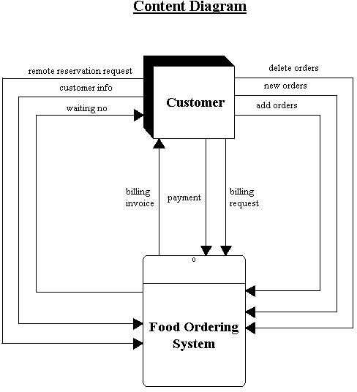

Fig 5.1 **Design**

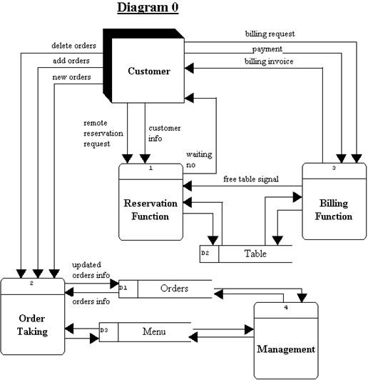s

Fig 5.2 **Ordering Diagram**

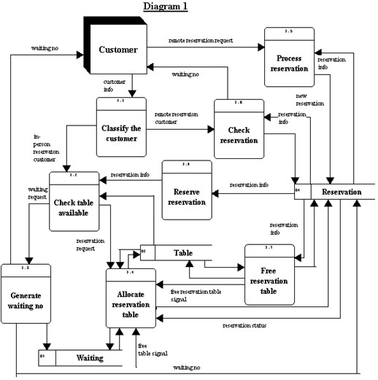

Fig 5.3 **Content Order**

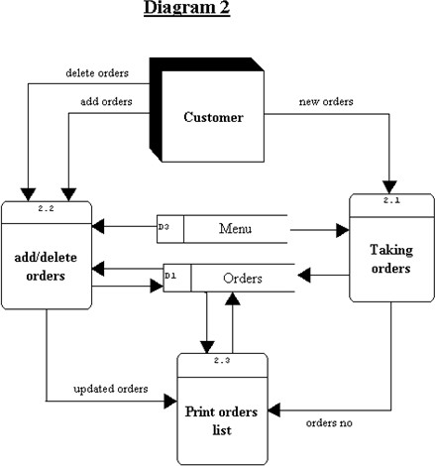

Fig 5.4 **Update Order**

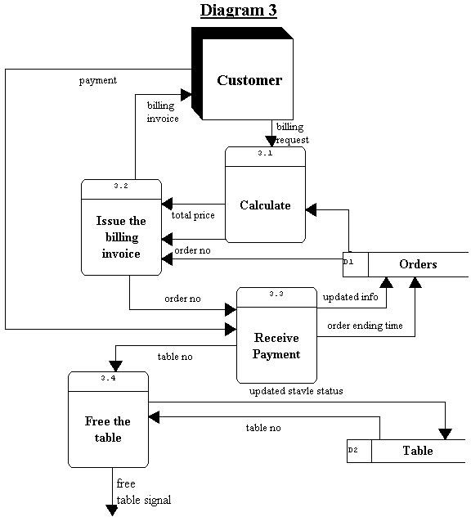

Fig 5.5 **Payment System**

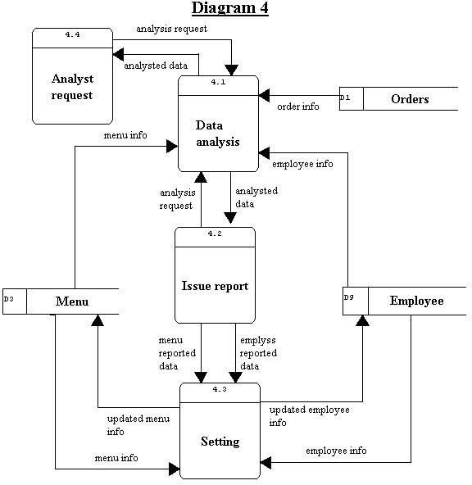

Fig 5.6 **Issue Report**

**CHAPTER 6**

**NON-FUNCTIONAL REQUIREMENTS**

All the application data is stored in a SQL database, and therefore a SQL Database must also be installed on the host computer. This software is freely available and can be installed and run under most operating systems. The server hardware can be any computer capable of running both the web and database servers and handling the expected traffic. For a small-scale restaurant that is not expecting to see much web traffic, an average personal computer may be appropriate. Once the site starts generating more hits, though, it will likely be necessary to upgrade to a dedicated host to ensure proper performance. The exact cutoffs will need to be determined through a more thorough stress testing of the system.

* 1. **Hardware Limitations:** The minimum hardware requirement for the system is 128 MB of Ram and a 60MB hard-disc drive.

**Others:** The application should be built using Java and JavaScript inscribed in HTML, and it should, initially, be accessible through the eclipse IDE and later published on a server System Evolution The heart of the entire ordering system is the Database. Currently the system is only available for small scale restaurants. For Large restaurants, performance considerations should be taken into account in terms of Hardware/Software capacity/Page load time etc. Also, security vulnerabilities should be evaluated for large scale systems. In future this can also be available as a Mobile application and can be integrated with in store Touch Screen Order devices. I am also certain that if this system goes into actual use, many requests will arise for additional features which I had not previously considered, but would be useful to have. For this reason, I feel as though the application can be constantly evolving, which I consider a very good thing. Conclusions and Future Work Conclusion: The main objective of the application is to help Computer Science students understands the basics of Java, JavaScript and HTML. The following results have been achieved after completing the system and relate back to the system’s objective.

* Should allow Computer Science students to browse through the code and application: This can be achieved when students are able to run and install the application. When they run the application, they can browse through the implementation of different objects.
* Should allow users to browse through different product categories: This is achieved through an easy- to-use graphical interface menu options.
* Should allow users to save items to the cart and view detailed information about the order: The users can add any number of items to the cart from any of the available food categories by simply clicking the Add to Cart button for each item. Once item is added to the cart, user is presented with detailed order to review or continue shopping.
* Should allow the user to Check out the item(s): This is achieved using the “Proceed to checkout button” in the cart initially and then “Checkout” button at last step after “review Order” step.. Button is disabled when there are no items in the cart.
* Should allow the user to process the payment: This is achieved when user selects “Processed to Checkout” button and fill up the Payment information details.
* Should allow the user to see Success message after placing an order: This is achieved when user successfully places an order. The user is given the order conformation number along with success message.
  1. **INTENDED AUDIENCE AND READINGSUGGESTIONS:**

This document is intended for any individual user, developer, tester, project manager or documentation writer that needs to understand the basic architecture and its specifications. Here are the potential uses for each one of the reader types:

* + 1. *Developer:*

The developer who wants to read, modify or add new requirements into the existing program, must firstly consult this document and update the requirements in appropriate manner.

* + 1. *User:*

The project has all the suitable requirements and has been implemented well.User of this program reviews the diagrams and the specifications presented in this document and determine.

* + 1. *Tester:*

The tester needs this document to validate that the initial requirement of this programs actually corresponds to the executable program correctly.

# CHAPTER 7 GRAPHICAL USER INTERFACE

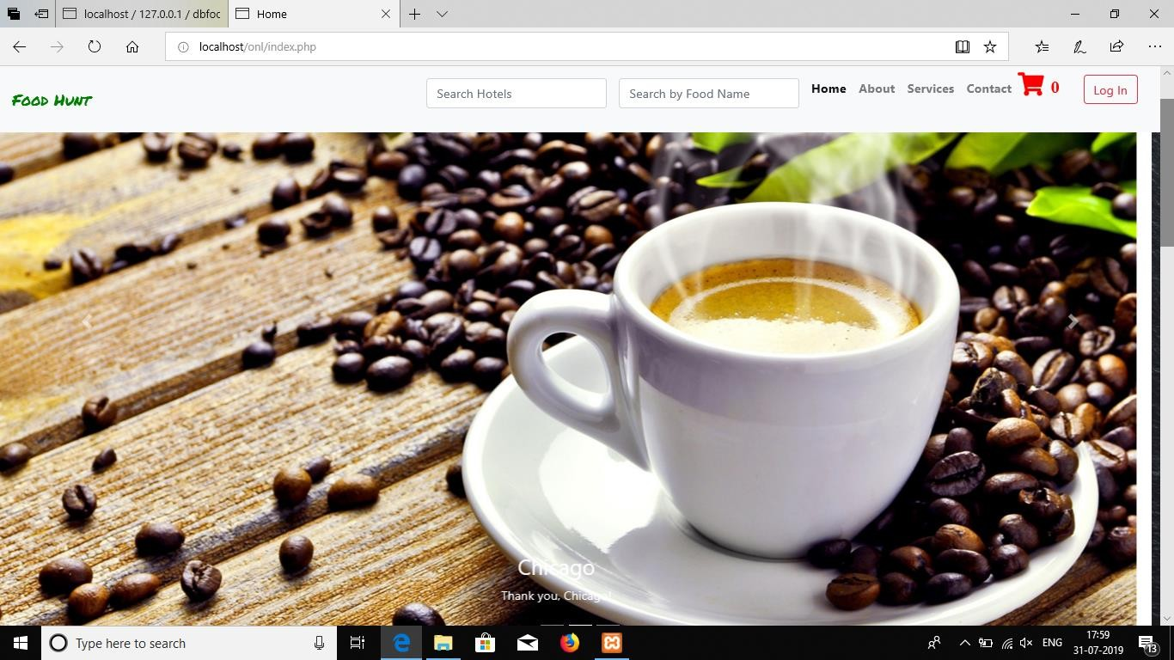

Fig 7.1 **Home Page(Slide 1)**

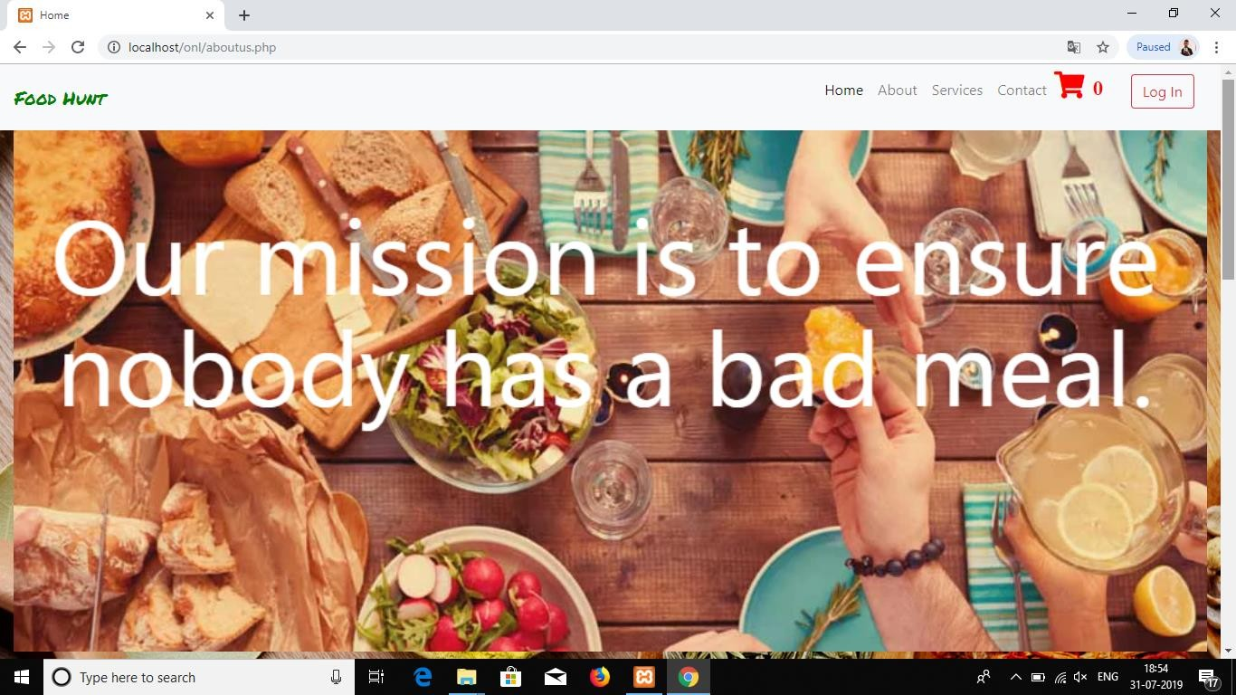

Fig 7.2 **Home Page(Slide 3)**

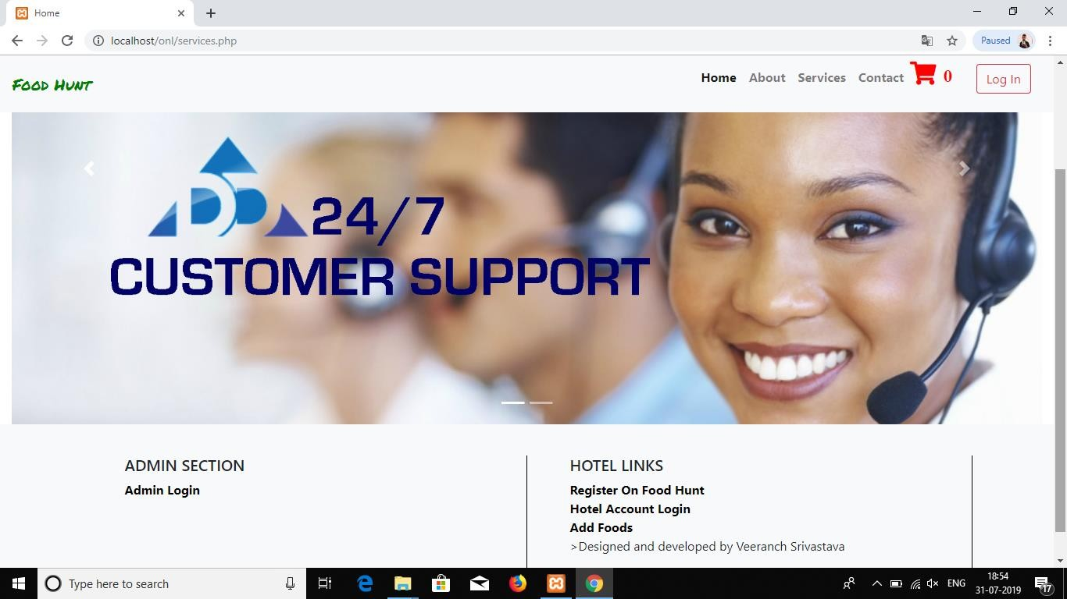

Fig 7.3 **Admin Section**

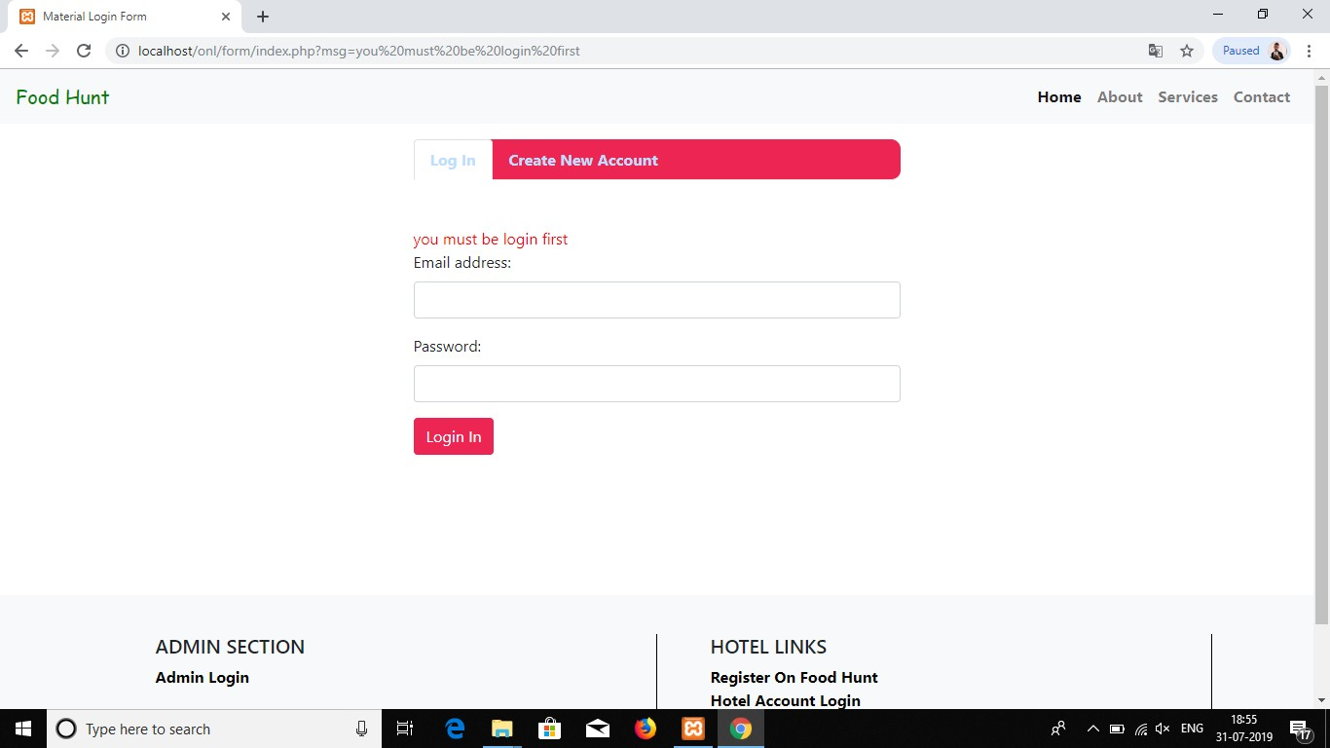

Fig 7.4 **Login Page**

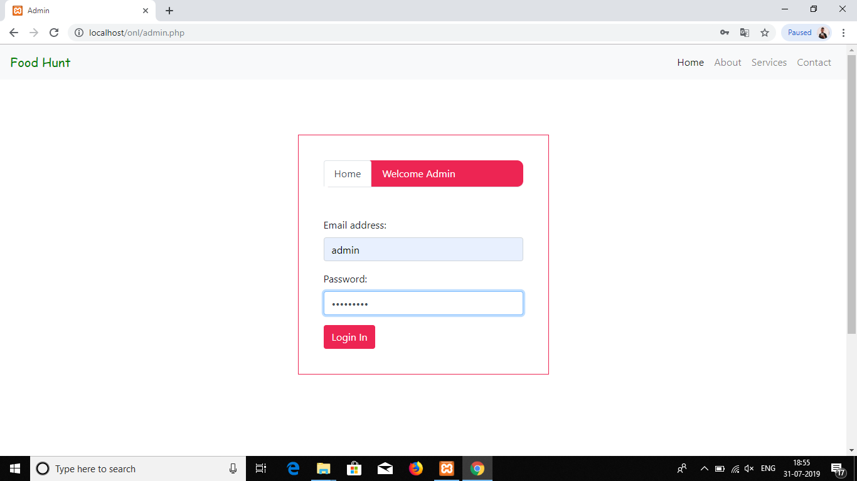

Fig 7.5 **Login Page for Admin**

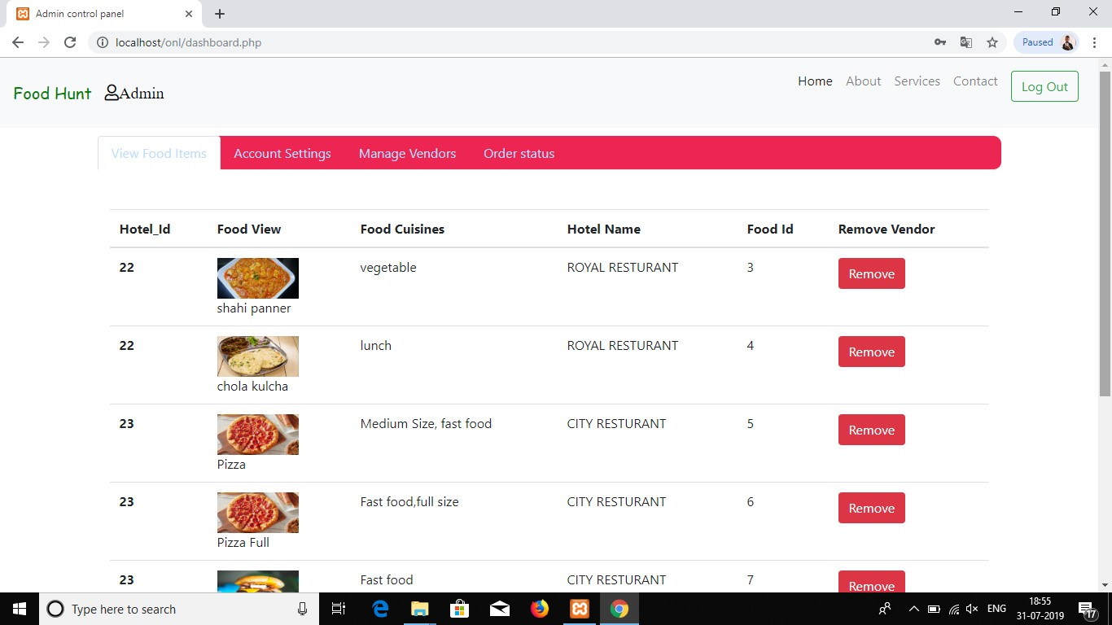

Fig 7.6 **Save Food Items**

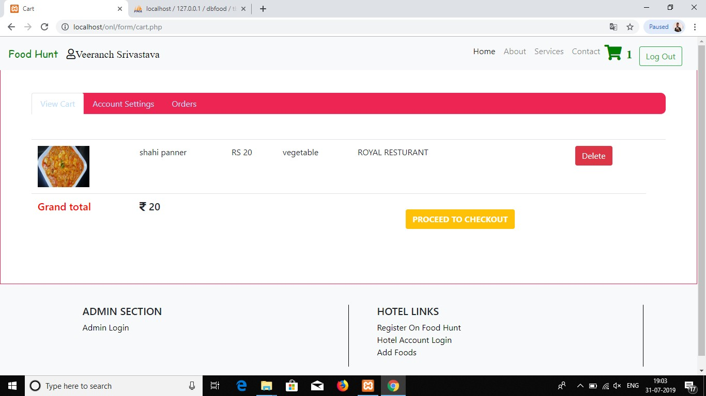

Fig 7.7 **View Cart**

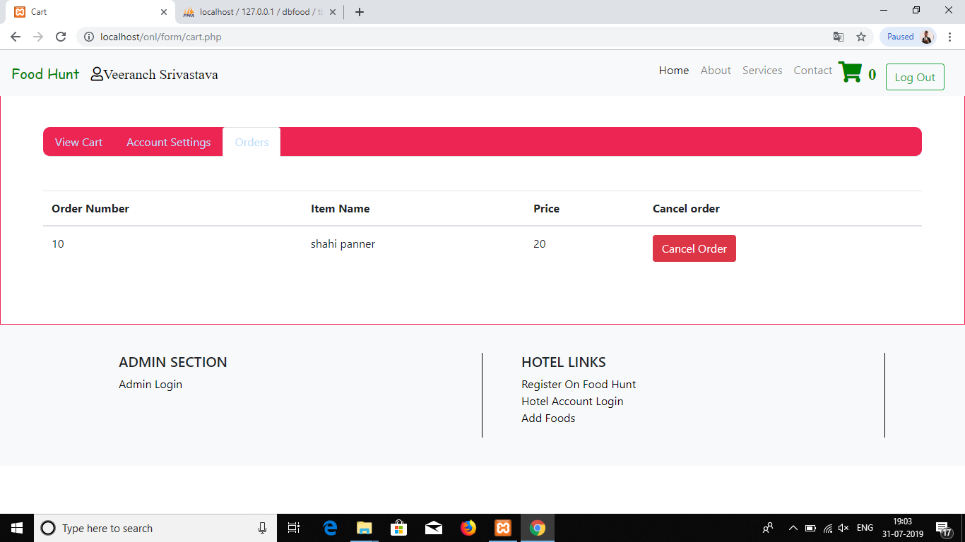

Fig 7.8 **Check Order**

**GLOSSARY**

|  |  |
| --- | --- |
| **Term** | **Definition** |
| User | Person who owns or uses the System. |
| Temporary Windows Files | Files created by the system or application programs for a shorter time period. Usually have .temp extension and resides in the temp folder.  (Path= "C:\Windows\Temp\"). |
| Encryption | **Encryption** is the most effective way to achieve data security. To read an **encrypted** file, you must have access to a secret key or password that enables you to decrypt it. Unencrypted data is called plain text.  **Encrypted** data is referred to as cipher text. |
| Temporary Internet Files | Files stored by the Web Browsers that allows websites to load more  quickly the next time they are visited. These files serve as cache for the web browsers. |
| Decryption | **Decryption** is the process of taking encoded or encrypted text or other data and converting it back into text that you or the computer can read and understand. This term could be used to describe a method of un-  encrypting the data manually or with un-encrypting the data using the proper codes or keys. |
| Empty Recycle Bin | Deleted files from system are still stored in the recycle bin.  Recycle Bin can be emptied to free up the space. |
| Back-up of  Documents | Zip files of the important documents are created for future reference in  case of unexpected loss of data. |
| Digital Password  Verification System | Image is used as a password. |

# CONCLUSION

Thus, we sure that my project, which is “ONLINE FOOD ORDERING SYSTEM” will be of great use to all customers as well as Restaurant the time and cost required is very less here, and by this project we can easily order food by sitting at hammer in our offices.

# REFRENCES

## Iztok Fajfar, Start Programming Using HTML, CSS, and JavaScript, Chapman and Hall/CRC, 9780429083457, 2015, 21 October 2015.

## Travis Faas, An Introduction to HTML5 Game Development with Phaser.js, A K Peters/CRC Press, 9781315363868, 2017, 20 January 2017.

## ASZachary Friggstad, Jörg-Rüdiger Sack, Mohammad R Salavatipour, Algorithms and Data Structures, 16th International Symposium, WADS 2019, Edmonton, AB, Canada, volume 11646 Proceedings, 2019, August 5–7.

## William Turner, Steve Leonard, JavaScript for Sound Artists, Routledge, 9781315659732, 2017, 18 January 2017.

## Satya eswari Jujjavarapu, Swasti Dhagat, Manisha Yadav, Computer-Aided Design of Antimicrobial Lipopeptides as Prospective Drug Candidates, CRC Press, 9781351018302, 2019, 16 September 2019.

## John Hunt, A Beginners Guide to Python 3 Programming, Springer, Cham, 978-3-030-20290-3, 2019.

## John Hunt, Advanced Guide to Python 3 Programming, Springer Nature Switzerland, 978-3-030-25942-6, 2019.

## John H. Reppy, Concurrent Programming in ML, Cambridge University Press, 9780511574962, 1999, October 2009.

## D. B. Skillicorn, Foundations of Parallel Programming, Cambridge University Press, 9780511526626, 2004, October 2009

## Josep Silva, Functional and Constraint Logic Programming, Springer Cham,978-3-030-16202-3, 2019

## Richard Wiener, Fundamentals of OOP and Data Structures in Java, Cambridge University Press, 9780511807176, 2000, June 2012.

## Bill Campbell, Swami Iyer, Bahar Akbal-Delibas, Introduction to Compiler Construction in a Java World, Chapman and Hall/CRC, 9780429067747, 2012, 3 December 2012.

## Quentin Charatan Aaron Kans, Java in Two Semesters, Springer, Cham, 978- 3-319-99420-8.

## Ramakrishnan, Raghu, Database Management Systems, Mcgraw Hill, 9789351345541, 2013.

## Fabrizio Riguzzi, Elena Bellodi, Riccardo ZeseInductive Logic Programming, 978-3-319-99960-9, 201

# CODING

#### ADMIN: -

<?php session_start();

include(“connection.php”); extract($_REQUEST); if(isset($login))

{

$sql=mysqli_query($con,”select * from tbadmin where fld_username=’$username’ && fld_password=’$pswd’ “);

if(mysqli_num_rows($sql))

{

$_SESSION[‘admin’]=$username;

header(‘location:dashboard.php’);

}

else

{

$admin_login_error=”Invalid Username or Password”;

}

}

?>

<!DOCTYPE html>

<html lang=”en” >

<head>

<meta charset=”UTF-8”>

<title>Admin</title>

<link rel=”stylesheet” href=”https://stackpath.bootstrapcdn.com/bootstrap/4.3.1/css/bootstrap.min.css” integrity=”sha384- ggOyR0iXCbMQv3Xipma34MD+Dh/1Fq784/j6Cy/iJTQUOhcWr7x9JvoRxT2MZw1T” crossorigin=”anonymous”>

<script src=”https://code.jquery.com/jquery-3.3.1.slim.min.js” integrity=”sha384- q8i/X+965DzO0Rt7abK41JStQIAqVgRVzpbzo5smXKp4YfRvH+8abtTE1Pi6jizo” crossorigin=”anonymous”></script>

<script src=”https://cdnjs.cloudflare.com/ajax/libs/popper.js/1.14.7/umd/popper.min.js” integrity=”sha384-

UO2Et0CpHqdSJQ6hJty5KVphtPhzWj9WO1clHTMGa3JDZwrnQq4Sf86dIHNDz0W1” crossorigin=”anonymous”></script>

<script src=”https://stackpath.bootstrapcdn.com/bootstrap/4.3.1/js/bootstrap.min.js” integrity=”sha384- JjSmVgyd0p3Pxb1rRibZUAYoIIy6OrQ6VrjIEaFf/nJGzIxFDsf4x0Xim+B07Jrm” crossorigin=”anonymous”></script>

<link rel=”stylesheet” href=”https://use.fontawesome.com/releases/v5.8.1/css/all.css” integrity=”sha384- 50oBUHEmvpQ+1Lw4y57PTFmhCaXp0ML5d60M1M7Uh2+nqUivzIebhndOJK28anvf” crossorigin=”anonymous”>

<style>

ul li{list-style:none;}

ul li a {color:black; text-decoration:none;}

ul li a:hover {color:black; text-decoration:none;}

</style>

</head>

<body>

<nav class=”navbar navbar-expand-lg navbar-light bg-light fixed-top”>

<a class=”navbar-brand” href=”index.php”><span style=”color:green;font-family: ‘Permanent Marker’, cursive;”>Food Hunt</span></a>

<button class=”navbar-toggler” type=”button” data-toggle=”collapse” data- target=”#navbarResponsive” aria-controls=”navbarResponsive” aria-expanded=”false” aria- label=”Toggle navigation”>

<span class=”navbar-toggler-icon”></span>

</button>

<div class=”collapse navbar-collapse” id=”navbarResponsive”>

<ul class=”navbar-nav ml-auto”>

<li class=”nav-item active”>

<a class=”nav-link” href=”index.php”>Home

</a>

</li>

<li class=”nav-item”>

<a class=”nav-link” href=”aboutus.php”>About</a>

</li>

<li class=”nav-item”>

<a class=”nav-link” href=”services.php”>Services</a>

</li>

<li class=”nav-item”>

<a class=”nav-link” href=”contact.php”>Contact</a>

</li>

</ul>

</div>

</nav>

<br><br><br><br><br><br>

<div class=”middle” style=” padding:40px; border:1px solid #ED2553; margin:0px auto; width:400px;”>

<ul class=”nav nav-tabs nabbar_inverse” id=”myTab” style=”background:#ED2553;border- radius:10px 10px 10px 10px;” role=”tablist”>

<li class=”nav-item”>

<a class=”nav-link active” id=”home-tab” data-toggle=”tab” href=”#login” role=”tab” aria- controls=”home” aria-selected=”true”>Home</a>

</li>

<a class=”nav-link” id=”profile-tab” style=”color:white;” aria-controls=”profile” aria- selected=”false”>Welcome Admin</a>

</ul>

<br><br>

<div class=”tab-content” id=”myTabContent”>

<!—login Section—starts→

<div class=”tab-pane fade show active” id=”login” role=”tabpanel” aria-labelledby=”home- tab”>

<div class=”footer” style=”color:red;”><?php if(isset($loginmsg)){ echo

$loginmsg;}?></div>

<form method=”post” enctype=”multipart/form-data”>

<div class=”form-group”>

<label for=”email”>Email address:</label>

<input type=”text” class=”form-control” name=”username” id=”email” required/>

</div>

<div class=”form-group”>

<label for=”pwd”>Password:</label>

<input type=”password” name=”pswd” class=”form-control” id=”pwd” required/>

</div>

<button type=”submit” name=”login” style=”background:#ED2553; border:1px solid #ED2553;” class=”btn btn-primary”>Login In</button>

<div class=”footer” style=”color:red;”><?php if(isset($admin_login_error)) { echo

$admin_login_error; }?></div>

<div class=”footer” style=”color:green;”><?php if(isset($_SESSION[‘pas_update_success’])) { echo $_SESSION[‘pas_update_success’];

}?></div>

</form>

</div>

<!—login Section—ends→

</div>

</div>

<br><br><br><br><br><br><br>

<?php include(“footer.php”);

?>

</body>

</html>

#### CONTACT: -

<?php session_start();

include(“connection.php”); extract($_REQUEST);

$arr=array();

if(isset($_SESSION[‘cust_id’]))

{

$cust_id=$_SESSION[‘cust_id’];

$qq=mysqli_query($con,”select * from tblcustomer where fld_email=’$cust_id’”);

$qqr= mysqli_fetch_array($qq);

}

else

{

$cust_id=””;

}

$query=mysqli_query($con,”select tblvendor.fld_name,tblvendor.fldvendor_id,tblvendor.fld_email,

tblvendor.fld_mob,tblvendor.fld_address,tblvendor.fld_logo,tbfood.food_id,tbfood.foodname

,tbfood.cost,

tbfood.cuisines,tbfood.paymentmode

from tblvendor inner join tbfood on tblvendor.fldvendor_id=tbfood.fldvendor_id;”); while($row=mysqli_fetch_array($query))

{

$arr[]=$row[‘food_id’]; shuffle($arr);

}

//print_r($arr);

if(isset($addtocart))

{

if(!empty($_SESSION[‘cust_id’]))

{

$_SESSION[‘cust_id’]=$cust_id; header(“location:form/cart.php?product=$addtocart”);

}

else

{

header(“location:form/?product=$addtocart”);

}

}

if(isset($login))

{

header(“location:form/index.php”);

}

if(isset($logout))

{

session_destroy(); header(“location:index.php”);

}

if(isset($message))

{

echo $name; echo $msgtxt; echo $email; echo $phone;

if(mysqli_query($con,”insert into tblmessage(fld_name,fld_email,fld_phone,fld_msg) values (‘$name’,’$email’,’$phone’,’$msgtxt’)”))

{

echo “<script> alert(‘We will be Connecting You shortly’)</script>”;

}

else

{

echo “failed”;

}

}$query=mysqli_query($con,”select tbfood.foodname,tbfood.fldvendor_id,tbfood.cost,tbfood.cuisines,tbfood.fldimage,tblcart.fld_ cart_id,tblcart.fld_product_id,tblcart.fld_customer_id from tbfood inner join tblcart on tbfood.food_id=tblcart.fld_product_id where tblcart.fld_customer_id=’$cust_id’”);

$re=mysqli_num_rows($query);

?>

<html>

<head>

<title>Contact-us</title>

<link rel=”stylesheet” href=”https://stackpath.bootstrapcdn.com/bootstrap/4.3.1/css/bootstrap.min.css” integrity=”sha384- ggOyR0iXCbMQv3Xipma34MD+Dh/1Fq784/j6Cy/iJTQUOhcWr7x9JvoRxT2MZw1T” crossorigin=”anonymous”>

<script src=”https://code.jquery.com/jquery-3.3.1.slim.min.js” integrity=”sha384- q8i/X+965DzO0Rt7abK41JStQIAqVgRVzpbzo5smXKp4YfRvH+8abtTE1Pi6jizo” crossorigin=”anonymous”></script>

<script src=”https://cdnjs.cloudflare.com/ajax/libs/popper.js/1.14.7/umd/popper.min.js” integrity=”sha384- UO2Et0CpHqdSJQ6hJty5KVphtPhzWj9WO1clHTMGa3JDZwrnQq4Sf86dIHNDz0W1” crossorigin=”anonymous”></script>

<script src=”https://stackpath.bootstrapcdn.com/bootstrap/4.3.1/js/bootstrap.min.js” integrity=”sha384-

JjSmVgyd0p3Pxb1rRibZUAYoIIy6OrQ6VrjIEaFf/nJGzIxFDsf4x0Xim+B07Jrm” crossorigin=”anonymous”></script>

<link href=”https://fonts.googleapis.com/css?family=Lobster” rel=”stylesheet”>

<link rel=”stylesheet” href=”path/to/font-awesome/css/font-awesome.min.css”>

<link rel=”stylesheet” href=”https://use.fontawesome.com/releases/v5.8.1/css/all.css” integrity=”sha384- 50oBUHEmvpQ+1Lw4y57PTFmhCaXp0ML5d60M1M7Uh2+nqUivzIebhndOJK28anvf” crossorigin=”anonymous”>

<script src=”https://ajax.googleapis.com/ajax/libs/jquery/2.1.3/jquery.min.js”></script>

<link href=”https://fonts.googleapis.com/css?family=Great+Vibes|Permanent+Marker” rel=”stylesheet”>

<style>

.carousel-item { height: 100vh;

min-height: 350px;

background: no-repeat center center scroll;

-webkit-background-size: cover;

-moz-background-size: cover;

-o-background-size: cover; background-size: cover;

}

</style>

<script>

//search product function

$(document).ready(function(){

$(“#search_text”).keypress(function()

{

load_data();

function load_data(query)

{

$.ajax({ url:”fetch.php”, method:”post”, data:{query:query}, success:function(data)

{

$(‘#result’).html(data);

}

});

}

$(‘#search_text’).keyup(function(){ var search = $(this).val();

if(search != ‘’)

{

load_data(search);

}

else

{

load_data();

}

});

});

});

</script>

<style>

ul li {list-style:none;}

ul li a{color:black; font-weight:bold;} ul li a:hover{text-decoration:none;}

</style>

</head>

<body>

<div id=”result” style=”position:fixed;top:100; right:50;z-index: 3000;width:350px;background:white;”></div>

<!—navbar start→

<nav class=”navbar navbar-expand-lg navbar-light bg-light fixed-top”>

<a class=”navbar-brand” href=”index.php”><span style=”color:green;font-family: ‘Permanent Marker’, cursive;”>Food Hunt</span></a>

<?php if(!empty($cust_id))

{

?>

<a class=”navbar-brand” style=”color:black; text-decoratio:none;”><I class=”far fa- user”><?php if(isset($cust_id)) { echo $qqr[‘fld_name’]; }?></i></a>

<?php

}

?>

<button class=”navbar-toggler” type=”button” data-toggle=”collapse” data- target=”#navbarResponsive” aria-controls=”navbarResponsive” aria-expanded=”false” aria- label=”Toggle navigation”>

<span class=”navbar-toggler-icon”></span>

</button>

<div class=”collapse navbar-collapse” id=”navbarResponsive”>

<ul class=”navbar-nav ml-auto”>

<li class=”nav-item active”>

<a class=”nav-link” href=”index.php”>Home

</a>

</li>

<li class=”nav-item”>

<a class=”nav-link” href=”aboutus.php”>About</a>

</li>

<li class=”nav-item”>

<a class=”nav-link” href=”services.php”>Services</a>

</li>

<li class=”nav-item”>

<a class=”nav-link” href=”contact.php”>Contact</a>

</li>

<li class=”nav-item”>

<form method=”post”>

<?php if(empty($cust_id))

{

?>

<a href=”form/index.php?msg=you must be login first”><span style=”color:red; font- size:30px;”><I class=”fa fa-shopping-cart” aria-hidden=”true”><span style=”color:red;”

id=”cart” class=”badge badge-light”>0</span></i></span></a>

&nbsp;&nbsp;&nbsp;

<button class=”btn btn-outline-danger my-2 my-sm-0” name=”login” type=”submit”>Log In</button>&nbsp;&nbsp;&nbsp;

<?php

}

else

{

?>

<a href=”form/cart.php”><span style=” color:green; font-size:30px;”><I class=”fa fa- shopping-cart” aria-hidden=”true”><span style=”color:green;” id=”cart” class=”badge badge-light”><?php if(isset($re)) { echo $re; }?></span></i></span></a>

<button class=”btn btn-outline-success my-2 my-sm-0” name=”logout” type=”submit”>Log Out</button>&nbsp;&nbsp;&nbsp;

<?php

}

?>

</form>

</li>

</ul>

</div>

</nav>

<!—navbar ends→

<br><br><br>

<div class=”container-fluid”>

<img src=”img/contact.bmp” width=”100%”>

</div>

<br>

<div class=”container”>

<div class=”row”>

<div class=”col-sm-8” style=”padding:20px; border:1px solid #F0F0F0;”>

<form method=”post”>

<div class=”form-group”>

<input type=”text” class=”form-control” placeholder=”Name*” name=”name” required/>

</div>

<div class=”form-group”>

<input type=”email” class=”form-control” placeholder=”email*” value=”<?php if(isset($cust_id)) echo $cust_id; ?>” name=”email” required/>

</div>

<div class=”form-group”>

<input type=”tel” class=”form-control” pattern=”[6-9]{1}[0-9]{9}” name=”phone” placeholder=”Phone(optinal) EX 9213298761”/>

</div>

<div class=”form-group”>

<textarea class=”form-control” placeholder=”Message*” name=”msgtxt” rows="3" col="10" required/></textarea/>

</div>

<div class="form-group">

<button type="submit" name="message" class="btn btn-danger">Send Message</button>

</div>

</form>

</div>

<div class="col-sm-4" style="padding:30px;">

<div class="form-group">

<i class="fa fa-phone" aria-hidden="true"></i>&nbsp;<b>9517050272</b><br><br>

<i class="fa fa-home" aria-hidden="true"></i>&nbsp; Veerunch Srivastava,Ayodhya,U.P<br>(24*7 Days)

</div>

</div>

</div>

</div>

<br><br>

<?php include("footer.php");

?>

</body>

</html>

#### DELETE-FOOD:-

<?php include('connection.php');

//echo $id=$_GET['id']; if(isset($_GET['id']))

{

$id=$_GET['id'];

$q=mysqli_query($con,"select tbfood.fldimage,tblvendor.fld_email from tbfood inner join tblvendor on tbfood.fldvendor_id=tbfood.fldvendor_id where food_id='$id' ");

$res=mysqli_fetch_assoc($q);

$e=$res['fld_email'];

$img=$res['fldimage']; unlink("image/restaurant/$e/foodimages/$img"); if(mysqli_query($con,"delete from tbfood where food_id='$id' "))

{

header( "refresh:5;url=dashboard.php" );

}

else

{

echo "failed to delete";

}

}

else

{

header("location:vendor_login.php");

}

//rmdir("image/$e/foodimages");

//rmdir("image/$e");

if(mysqli_query($con,"delete from tbfood where food_id='$id' "))

{

header( "refresh:5;url=dashboard.php" );

}

else

{

echo "failed to delete";

}

?>

<html>

<head>

<title>Hotel</title>

<link rel="stylesheet" href="https://stackpath.bootstrapcdn.com/bootstrap/4.3.1/css/bootstrap.min.css" integrity="sha384- ggOyR0iXCbMQv3Xipma34MD+dH/1fQ784/j6cY/iJTQUOhcWr7x9JvoRxT2MZw1T" crossorigin="anonymous">

<script src="https://code.jquery.com/jquery-3.3.1.slim.min.js" integrity="sha384- q8i/X+965DzO0rT7abK41JStQIAqVgRVzpbzo5smXKp4YfRvH+8abtTE1Pi6jizo" crossorigin="anonymous"></script>

<script src="https://cdnjs.cloudflare.com/ajax/libs/popper.js/1.14.7/umd/popper.min.js" integrity="sha384- UO2eT0CpHqdSJQ6hJty5KVphtPhzWj9WO1clHTMGa3JDZwrnQq4sF86dIHNDz0W1" crossorigin="anonymous"></script>

<script src="https://stackpath.bootstrapcdn.com/bootstrap/4.3.1/js/bootstrap.min.js" integrity="sha384- JjSmVgyd0p3pXB1rRibZUAYoIIy6OrQ6VrjIEaFf/nJGzIxFDsf4x0xIM+B07jRM" crossorigin="anonymous"></script>

<style>

h1 {

text-align: center; font-size: 60px; margin-top: 0px;

}

p {

text-align: center; font-size: 60px; margin-top: 0px;

}

</style>

</head>

<body>

<div class="container" style="margin:0px auto;text-align:center;">

<p style="color:green;"> Please Wait We Are Updating</p>

<img src="img/lg.walking-clock-preloader.gif"/></div>

<h1><time>00</time></h1>

<script>

var h1 = document.getElementsByTagName('h1')[0], start = document.getElementById('start'),

stop = document.getElementById('stop'), clear = document.getElementById('clear'),

seconds = 0, minutes = 0, hours = 0, t;

function add() { seconds++;

if (seconds >= 60) { seconds = 0; minutes++;

if (minutes >= 60) { minutes = 0; hours++;

}

}

h1.textContent = (seconds > 9 ? seconds : "0" + seconds);

timer();

}

function timer() {

t = setTimeout(add, 1000);

}

timer();

</script>

</body>

FORM:-

<?php session_start();

include("../connection.php"); extract($_REQUEST); if(isset($_GET['product']))

{

$product_id= $_GET['product'];

}

else

{

$product_id= "";

}

if(isset($login))

{

$query=mysqli_query($con,"select * from tblcustomer where fld_email='$email' && password='$password'");

if($row=mysqli_fetch_array($query))

{

$customer_email =$row['fld_email'];

$_SESSION['cust_id']=$customer_email; if(!empty($customer_email && $product_id))

{

//$_SESSION['product']=$product_id;

echo $_SESSION['cust_id']=$customer_email;

header("location:cart.php?product=$product_id");

}

else

{

header("location:../index.php");

$_SESSION['product']=$product_id;

$_SESSION['cust_id'];

}

}

else

{

$ermsg="invalid Details";

}

}

if(isset($register))

{

$query=mysqli_query($con,"select * from tblcustomer where fld_email='$email'");

$row=mysqli_num_rows($query); if($row)

{

$ermsg2="Email alredy registered with us";

}

else

{

if(mysqli_query($con,"insert into tblcustomer (fld_name,fld_email,password,fld_mobile) values('$name','$email','$password','$mobile')"))

{

$_SESSION['cust_id']=$email; if(!empty($customer_email && $product_id))

{

$_SESSION['cust_id']=$customer_email; header("location:cart.php?product='$product_id'");

}

else

{

$_SESSION['cust_id']=$email;

header("location:../index.php");

}

}

else

{

echo "fail"; echo $name; echo $email;

echo $password; echo $mobile;

}

}

}

?>

<!DOCTYPE html>

<html lang="en" >

<head>

<meta charset="UTF-8">

<title>Material Login Form</title>

<link rel="stylesheet" href="https://stackpath.bootstrapcdn.com/bootstrap/4.3.1/css/bootstrap.min.css" integrity="sha384- ggOyR0iXCbMQv3Xipma34MD+dH/1fQ784/j6cY/iJTQUOhcWr7x9JvoRxT2MZw1T" crossorigin="anonymous">

<script src="https://code.jquery.com/jquery-3.3.1.slim.min.js" integrity="sha384- q8i/X+965DzO0rT7abK41JStQIAqVgRVzpbzo5smXKp4YfRvH+8abtTE1Pi6jizo" crossorigin="anonymous"></script>

<script src="https://cdnjs.cloudflare.com/ajax/libs/popper.js/1.14.7/umd/popper.min.js" integrity="sha384- UO2eT0CpHqdSJQ6hJty5KVphtPhzWj9WO1clHTMGa3JDZwrnQq4sF86dIHNDz0W1" crossorigin="anonymous"></script>

<script src="https://stackpath.bootstrapcdn.com/bootstrap/4.3.1/js/bootstrap.min.js" integrity="sha384- JjSmVgyd0p3pXB1rRibZUAYoIIy6OrQ6VrjIEaFf/nJGzIxFDsf4x0xIM+B07jRM" crossorigin="anonymous"></script>

<link rel="stylesheet" href="https://use.fontawesome.com/releases/v5.8.1/css/all.css" integrity="sha384- 50oBUHEmvpQ+1lW4y57PTFmhCaXp0ML5d60M1M7uH2+nqUivzIebhndOJK28anvf" crossorigin="anonymous">

<style> ul li{}

ul li a {color:white;padding:40px; }

ul li a:hover {color:white;}

</style>

</head>

<body>

<nav class="navbar navbar-expand-lg navbar-light bg-light fixed-top">

<a class="navbar-brand" href="index.php"><span style="color:green;font-family: 'Permanent Marker', cursive;">Food Hunt</span></a>

<button class="navbar-toggler" type="button" data-toggle="collapse" data- target="#navbarResponsive" aria-controls="navbarResponsive" aria-expanded="false" aria- label="Toggle navigation">

<span class="navbar-toggler-icon"></span>

</button>

<div class="collapse navbar-collapse" id="navbarResponsive">

<ul class="navbar-nav ml-auto">

<li class="nav-item active">

<a class="nav-link" href="../index.php">Home

</a>

</li>

<li class="nav-item">

<a class="nav-link" href="../aboutus.php">About</a>

</li>

<li class="nav-item">

<a class="nav-link" href="../services.php">Services</a>

</li>

<li class="nav-item">

<a class="nav-link" href="../contact.php">Contact</a>

</li>

</ul>

</div>

</nav>

<div class="middle" style=" position:fixed; padding:40px; border:1px solid #ED2553; left:30%; top:30%; width:400px;">

<ul class="nav nav-tabs nabbar_inverse" id="myTab" style="background:#ED2553;border- radius:10px 10px 10px 10px;" role="tablist">

<li class="nav-item">

<a class="nav-link active" id="home-tab" data-toggle="tab" href="#login" role="tab" aria- controls="home" aria-selected="true">Home</a>

</li>

<li class="nav-item">

<a class="nav-link" id="profile-tab" data-toggle="tab" href="#signup" role="tab" aria- controls="profile" aria-selected="false">Create New Account</a>

</li>

</ul>

<br><br>

<div class="tab-content" id="myTabContent">

<!--login Section-- starts-->

<div class="tab-pane fade show active" id="login" role="tabpanel" aria-labelledby="home- tab">

<form method="post" enctype="multipart/form-data">

<div class="form-group">

<label for="email">Email address:</label>

<input type="email" class="form-control" name="email" id="email" required/>

</div>

<div class="form-group">

<label for="pwd">Password:</label>

<input type="password" name="password" class="form-control" id="pwd" required/>

</div>

<button type="submit" name="login" style="background:#ED2553; border:1px solid #ED2553;" class="btn btn-primary">Login In</button>

<div class="footer" style="color:red;"><?php if(isset($ermsg)) { echo $ermsg; }?><?php if(isset($ermsg2)) { echo $ermsg2; }?></div>

</form>

</div>

<!--login Section-- ends-->

<!--new account Section-- starts-->

<div class="tab-pane fade" id="signup" role="tabpanel" aria-labelledby="profile-tab">

<form method="post" enctype="multipart/form-data">

<div class="form-group">

<label for="name">Name</label>

<input type="text" id="name" class="form-control" name="name" required="required"/>

</div>

<div class="form-group">

<label for="email">Email</label>

<input type="email" id="email" name="email" class="form-control" required/>

</div>

<div class="form-group">

<label for="pwd">Password:</label>

<input type="password" name="password" class="form-control" id="pwd" required/>

</div>

<div class="form-group">

<label for="mobile">Mobile</label>

<input type="tel" id="mobile" class="form-control" name="mobile" pattern="[6-9]{1}[0- 9]{2}[0-9]{3}[0-9]{4}" placeholder="" required>

</div>

<button type="submit" name="register" style="background:#ED2553; border:1px solid #ED2553;" class="btn btn-primary">Create New Account</button>

<div class="footer" style="color:red;"><?php if(isset($ermsg)) { echo $ermsg; }?><?php if(isset($ermsg2)) { echo $ermsg2; }?></div>

</form>

</div>

</div>

</div>

</body>